Subatomic Particle | Particles that make up atoms | 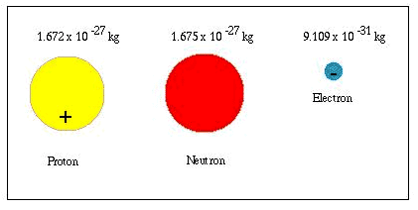
Atom | Smallest particle of an element with properties of element | 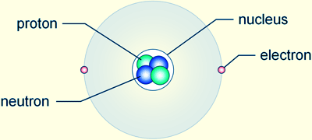
Molecule | Combinations of atoms | 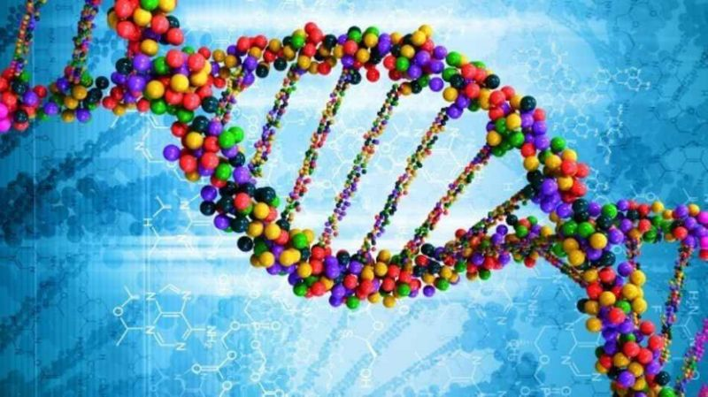
Organelle | Structure within cells that performs a specific function | 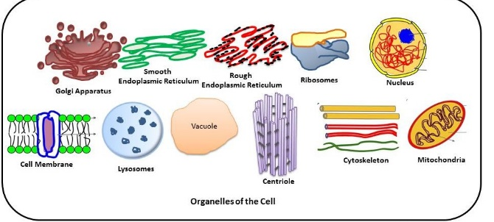
Cell | Smallest unit of life | 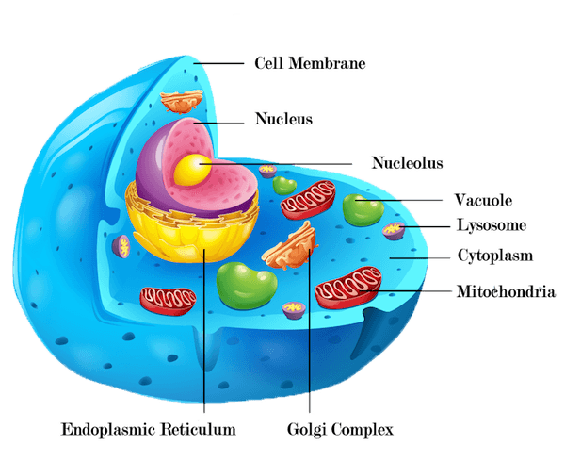
Tissue | A group of similar cells that perform a specific function | 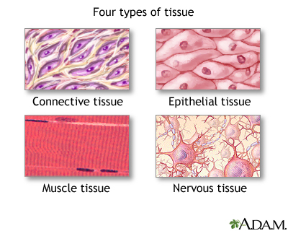
Organ | Structure composed of several tissues that form a functional unit | 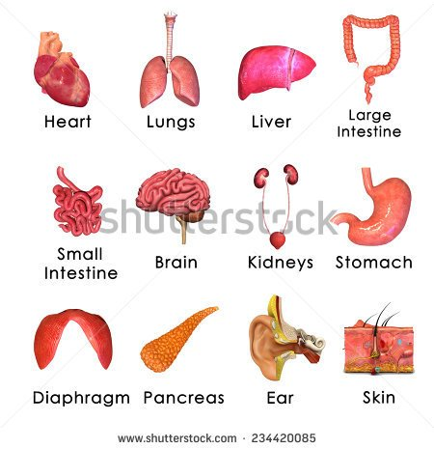
Organs System | Two or more organs working together to perform a specific function | 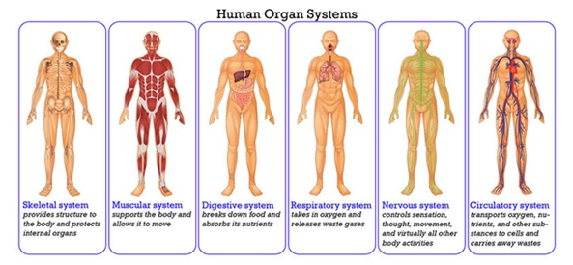
Organisms | One individual composed of many cells | 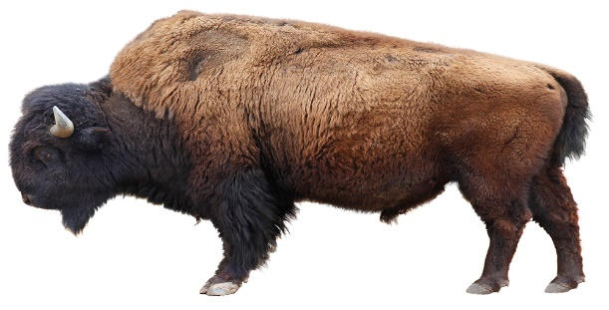
Population/ species | Members of the same species in the same area that can interbreed
Community | Two or more populations in same area
Ecosystem | Community and its non-living surroundings
Biosphere | Living and non-living components of habitable Earth

