Biology Cornell Notes: Macromolecule Notes Date:
Study Questions/ Vocabulary:  1.Which elements does carbon bond with to make life’s molecules?  _________________________________________________________________________________________________________________________________________________________  2. How are macromolecules formed? _________________________________________________________________________________________________________________________________________________________3. What makes a monosaccharide different from a polysaccharide? _________________________________________________________________________________________________________________________________________________________  4. Which type of lipid is solid at room temperature?  ________________________________________________________________________________________________________________________________________________________  5. What type of bond joins amino acids together? ________________________________________________________________________________________________________________________________________________________ | - Carbon Compounds  - A carbon atom can form ________________bonds with other atoms  - _______________________ ___________________ is the study of all compounds that contain bonds between ______________________ atoms  - These elements are most common in our cells _________________, __________________, __________________, __________________, __________________, and ____________________  - Remember: CHNOPS  - Macromolecules: __________________________________________________ _______________________________________________________  - Macromolecules are examples of _________________ which form when many smaller molecules ___________________ bond together usually in long chains  - Macromolecules in living things  - Carbohydrates.  - Lipids  - Nucleic acids  - Proteins  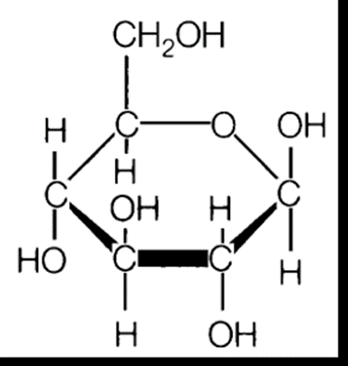  - Carbohydrates  - Elements: ________________, _____________, __________  - Ratio: __: ___: ___  - Function___________________________  - Monosaccharide: ____________________  Ex. __________________________  - Disaccharide: ______________________  Ex. ___________________________  - Polysaccharide: _____________________  Ex. __________________________  - Lipids (Fats)  - Elements ________________, ______________________  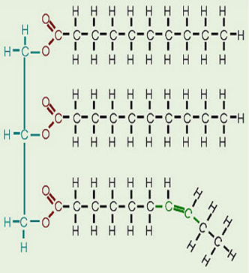  - Functions: _________________________ _________________________________  - Structure: Saturated Fats (Butter) ______________________________________  Unsaturated Fats (oil)___________________ _________________________________  2A. Lipids (Waxes)  - ________________________________  Ex. Fruits/ Leaves  2B. Phospholipids  - Responsible for the ______________________ and ________________ of the cell membrane  - Hydrophobic = ____________________________  - Hydrophilic= ______________________________  2C. Lipids (Steroids)  - _________________________________________________________________  - Cholesterol helps in the formation of Vitamin D and Hormones such as estrogen and testosterone  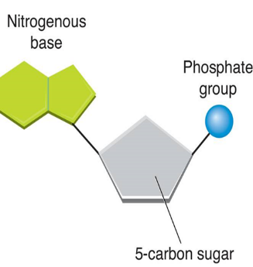  - Nucleic Acids  - Elements: _________________________________  - Function: store and transmit ___________________ information  - ______________________________: Monomer of a nucleic acid ( see picture )  - Proteins  - Elements: ___________________________________________________  - Functions: ___________________________________________________  ____________________________________________________________  ____________________________________________________________  - Amino Acids________________________ of proteins  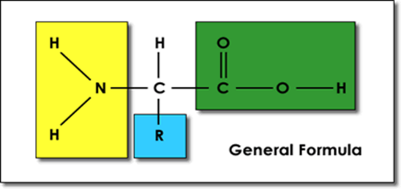  - 4 Groups  1) Hydrogen Atom  2) Amino Group  3) Carboxyl Group  4) R group (changes in each Amino Acid!)  d. Amino acids are joined together by _______________________ bonds  e. There are _________ different amino acids
SUMMARY : ________________________________________________________________________________________________________________________________________________________________________________________________________________________________________________________________________________________________________________________________________________________________________________________________________________________________________________________________________________________________________________________________________________________________________________________________

