name(s) ___________________________________________ Due Date __________________

Photosynthesis & Cellular respiration Project

Directions:
- Design a project that will show information about photosynthesis and cellular respiration and the connections between the two.
- You can show the relationship between the two in the following ways:
Song – at least 2 minutes long, any genre of music, lyrics typed, and song recorded with video to include images.
Recipe – must include all key terms, explain how to “mix” ingredients to get the final end products and include detailed images.
Educational Video - at least 2 minutes long, include all key terms, use demonstrations or visuals to explain information. (Think Amoeba Sisters)
Board game – can be based on any game. Must include 25 cards, a board and integrated images.
Comic book / Story- must include at least two characters, all key terms, visually appealing, colorful, and creative.
Infographic – must be well structured and cover the topic clearly with appropriate details and examples.

- Your Project Must Contain the Following Information:

- Cell respiration equation
- Cell respiration equation in word form
- Photosynthesis equation
- Photosynthesis equation in word form
- Glycolysis
- Krebs cycle
- Electron transport chain
- Light dependent reaction
- Light independent reaction
- Glucose
- Oxygen
- Water
- Sunlight
- Carbon Dioxide
- ATP
- Artwork, drawings, or pictures that depict what is happening in photosynthesis.
- Artwork, drawings, or pictures that depict what is happening in cellular respiration.
- A WRITTEN DESCRIPTION of how photosynthesis and cellular respiration ARE RELATED

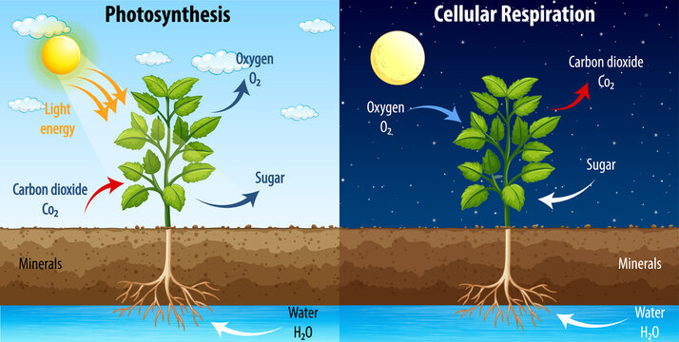

Photosynthesis and Cellular Respiration Project Rubric
Category | 10 Points | 8 Points | 6 Points | 4 Points | 0 Points | Self-Assessment | Teacher Assessment
Use of Class Time | Used class time well each class period. Focused on getting the project done. Never distracted others | Used class time well each class period. Usually focused on getting the project done. Never distracted others |  | There was some focus on getting the project done but occasionally distracted others | Did not use class time to focus on the project and often distracted others
Items to be included | Project includes all necessary items. All items of importance in the project are easy to find | Project is missing 1-2 items of importance. All remaining items of importance are easy to find | Project is missing 3-4 items of importance. Or items of importance are not easily found | Project is missing 5 or more items of importance and most of the items are not easily found | Poster is missing 6 or more items of importance, or they are not easily found.
Explanations Included (x2) | Project clearly explains the processes of photosynthesis and cellular respiration and how they are related. | Project clearly explains the processes of photosynthesis and cellular respiration but does not clearly explain how they are related. | Project attempts to but does not clearly explain the process of photosynthesis and cellular respiration  but does include an accurate explanation of how they are related. | Project attempts to but does not clearly explain the process of photosynthesis and cellular respiration or how they are related. | Project is missing one or more explanations of the processes of photosynthesis and cellular respiration, and fails to describe how they are related
Pictures | All pictures are related to the topic and make it easier to understand. | All pictures are related to the topic and most make it easier to understand | All pictures are vaguely related to the project | 1-2 pictures do not relate to the project | Graphics do not relate to the topic.
Neatness | The project is exceptional in terms of design, layout and neatness | The project is well done in terms of design, layout and neatness | The project is mostly well done, but a little messy in certain areas | The project is mostly messy, but is well done in one or two areas | The project is messy and unorganized
Self-Assessment | Self-assessment was completed accurately |  |  |  | Self-assessment was not completed
Project turned in on time | Project was received by the due date |  |  |  | Project is late
TOTAL POINTS |  |  |  |  |  | /80 | /80

