Dan-Nad Publishing
The way of the wolf
Issue 1, 13 October 2020
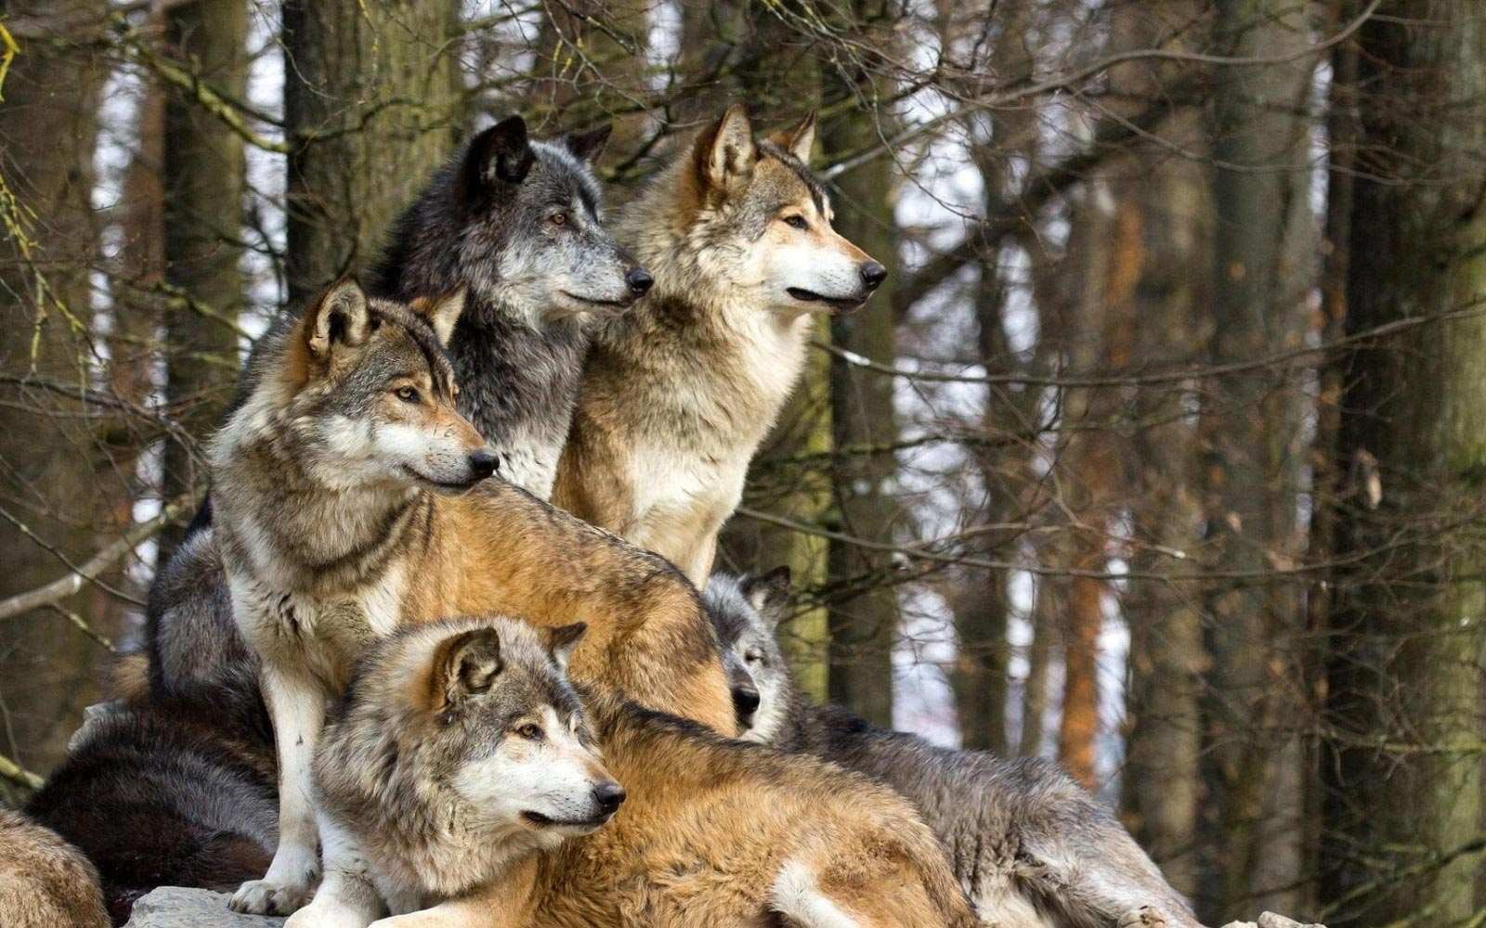  Wolf pack, Moonstone, shows similarities with cell organelles  This Photo by Unknown Author is licensed under CC BY-NC-ND |  |  |  |  |  |  | Evidence of vacuole and crick similarities found in forest Cline-Lib
Who has got the power?  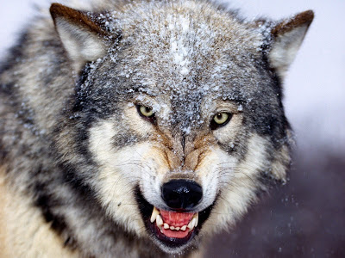  This Photo by Unknown Author is licensed under CC BY |  |  | One of the higher ranks of wolf pack Moonstone is the warrior wolf. Warrior wolves fight off the prey and hunters. They are known as the “power of the pack” due to their godly fighting skills. This is similar to the mitochondria cell organelle, for mitochondria’s are known as the “powerhouse of the cell”. |  |  | This week, the crick located in Cline-Lib Forest was reported to be a water source for wolf pack Moonstone. This crick stores water and nutrients for the pack. This is very similar to how a vacuole works. Vacuoles store water and nutrients for the cell.
Delta wolf spotted on its way to announce a message to its pack.
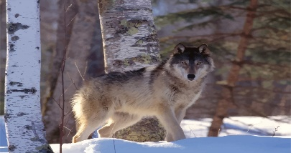
This Photo by Unknown Author is licensed under CC BY-NC-ND
Delta wolf on its way to deliver news to its trusted pack, Moonstone.

Delta wolf or Rough Endoplasmic Reticulum?  Written by Danielle Cline and Nadia Libreatori |  |  |  | Rough Endoplasmic Reticulum or Rough ER is the cell organelle that transports materials throughout the cell.  As you can tell, The Rough ER and Delta wolf are similar because they both transport things to something else.  Delta- to the pack  Rough ER-to the rest of the cell | 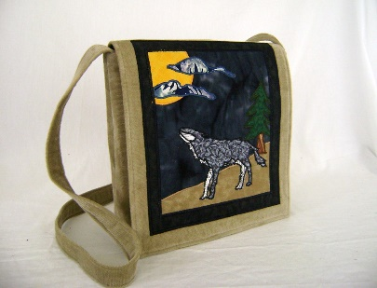  This Photo by Unknown Author is licensed under CC BY-SA-NC  Both are very fascinating concepts. Next time you see a Delta wolf, try recognizing its Rough ER characteristics.
Delta wolfs are third in command. They are known as the messenger, for they transport news throughout the pack | Knowing this, you can probably guess what cell organelle they are similar too.  You guessed it! The Rough Endoplasmic Reticulum.

 | Pack Moonshine consists of all ranks of wolves. The alpha, beta, delta, warrior, hunters, healers, omega.
Forest, The New Cell Wall  Written by Danielle Cline and Nadia Libreatori |  |  |  |  | Q: How is the forest, Cline-Lib, similar to the cell wall organelle?  A: “Forest Cline-Lib has always been home to my pack and I, mostly because it provides us with so much protection and support. Moonstone feels so protected here mostly because we are familiar with this forest, given that we have lived here for so many years. This forest also offers us so much support. Such as our den, our prey, and our crick for drinking. Forest Cline-Lib is similar to the cell wall because that organelle gives off the same protection and support to its cell but in a different way.” | 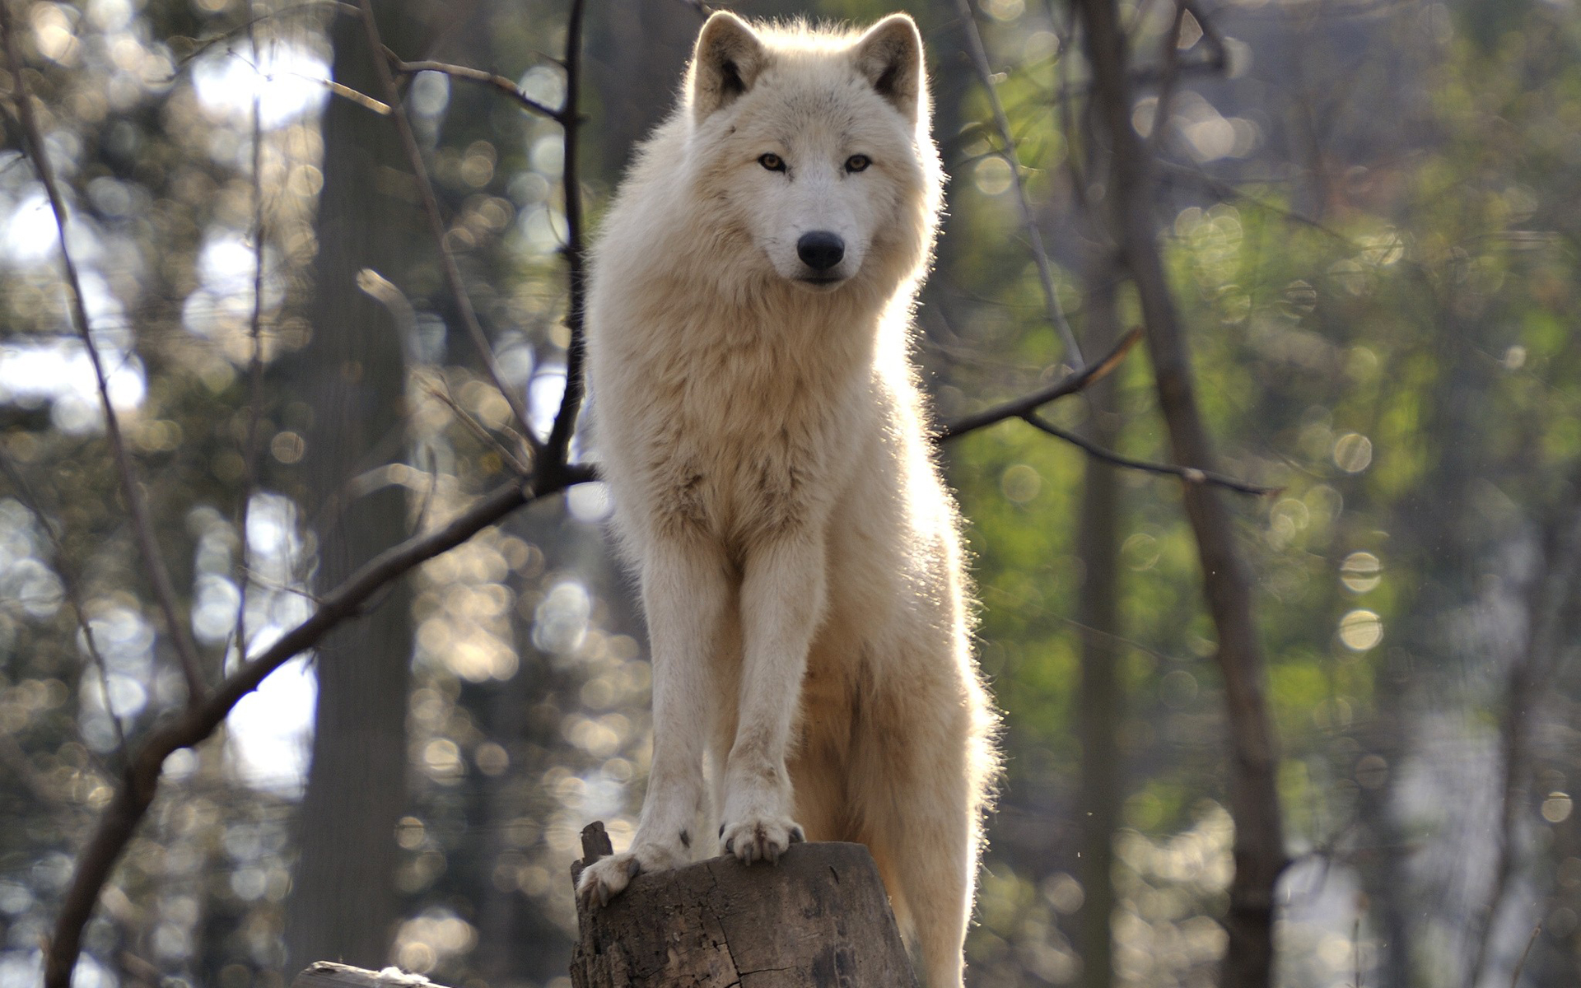  Picture of wolf pack, Moonstone’s, alpha wolf.  This Photo by Unknown Author is licensed under CC BY-SA
The Cline-Lib Forest is the Moonstone pack’s territory. This specific forest is where they feel most protected. The forest also helps support the packs needs by providing shelter, food, and water. |  | The forest and Cell wall are both similar because they both offer protection and support.  Forest- to the pack  Cell wall-to the cell
The cell wall is a very important organelle. The cell wall’s job is to protect and support the cell. |  | Alpha wolf explains how the forest acts like a cell wall

