Name______________________________________________Date______________Period_______
Yeast Respiration Lab

Question: How does sugar effect the carbon dioxide production in yeast?

In this lab, we will observe the effect of food sources on the process of fermentation by yeast. You will attempt to determine the effect of sugar on the rate of CO2 production.

Hypothesis: Make a prediction for what you think will happen during the lab given what you know about cellular respiration and fermentation. (Check out the procedure on the next page to better understand what you are doing during the lab). MUST BE AN IF/THEN STATEMENT
________________________________________________________________________________________________________________________________________________________________________

Materials:

- 2 Graduated tubes
- 2 Small beakers
- Test tube holder
- Yeast
- warm water
- table sugar
- graduated cylinder
- stir sticks
- Scoopula
- stop watch/phone

Procedure:

Part 1-
- Observe the labeled gradated tube sugar, and the other no sugar.
- In a small beaker add 4 scoopulas of yeast and 20ml of warm water.
- Mix thoroughly with stir stick (≈30seconds)
- In another small beaker add 4 scoopulas of yeast, 16 scoopulas of sugar and 20ml of warm
water. Mix thoroughly!

*WAIT at least 5 Min. FOR THE YEAST TO ACTIVATE

WHILE YOU WAIT FOR THE YEAST TO BECOME ACTIVE READ AND ANWER THE FOLLOWING QUESTIONS:

Did you ever wonder how bread gets its "spongy" structure? If you've ever baked homemade bread yourself, you know that you need yeast to make the bread dough rise. Yeast are tiny single-celled (unicellular) fungi. The organisms in the Kingdom Fungi are not capable of making their own food. Fungi, like any other organism, need food for energy. They rely on sugar found in their environment to provide them with this energy in order to grow and reproduce.

Yeast, like bacteria, grow in or on their food source. They produce and release digestive proteins (enzymes) into their environment where the sugar molecules are found. Complex sugar molecules are broken down into monosaccharides that can be absorbed by the yeast and used for food (energy). Bread recipes rely on yeast to break down sugars found in flour.

Yeast is a facultative anaerobe, meaning that it can participate in aerobic respiration when possible, but when this is impossible, it respires anaerobically. When using yeast in making dough, the yeast will use the initial oxygen up very quickly and then start to respire anaerobically. ATP will then be made via glycolysis, which requires no oxygen. Without oxygen present, the yeast will then undergo alcoholic fermentation, which produces CO2 and ethyl alcohol.

BACKGROUND INFO: Please use your book or your notes to help you research the following information.
1. Write down the equation for cellular respiration

+ +

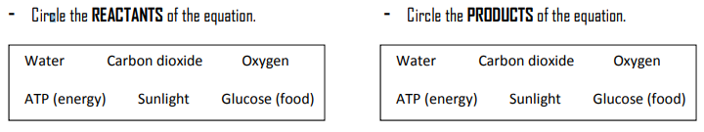
2. What would happen if an organism trying to respire had NO OXYGEN? Would the organisms still make ATP? ___________________________________________________________________________
3. What are YEAST and how do they obtain energy? What do they release as a WASTE PRODUCT? ___________________________________________________________________________
Yeast can take out more energy from sugar when oxygen is present in their environment. In the absence of oxygen, yeast switch to an alternative pathway that does not require oxygen. This process is called fermentation. With fermentation, yeast can still get energy from sugar, but less energy is made from each sugar molecule. This process allows the yeast to survive and grow where no oxygen is available.
Fermentation partially breaks down the sugar and a small amount of energy is captured in the form of ATP, and a different product is formed. During fermentation in yeast, the products are carbon dioxide and alcohol. Alcoholic fermentation in yeast can be used to make wine or beer.

Fermentation Equation:

C₆H₁₂O₆ 2(CH₃CH₂OH) + 2CO₂ + energy
(alcohol)

4. What waste product of yeast respiration is useful in making beer/wine? _____________

We can respire in both ways too. Normally we use oxygen, but when we are running in a race, we may not get enough oxygen into our blood, so our muscles start to respire without oxygen. Unlike yeast we produce lactic acid, this causes the ‘burning’ sensation and cramping in the muscles.

To measure the rate of alcoholic fermentation in yeast, you can measure the amount of CO₂ gas the yeast produces. CO₂ production can be measured by measuring the depth of the layer of bubbles trapped in foam on top of the yeast solution

- What are the two types of fermentation you read about? ________________________________________________________________________

Part 2-
- Pour yeast solution without sugar into tube labeled no sugar. Fill the tube all the way to the top, extending the fluid slightly above the top the tubes.
Yeast/sugar mixture
extending above the
top of the tube.
- Slowly screw the cap on the tube, some may squirt out, this is O.K.
- 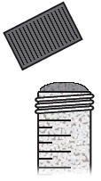Turn the tube upside down and check to see that there is only a small bubble or bubbles. It there is a large bubble, you need to add more of the mixture to the tubes and try again.
- Keep the tube upside down and place into the test tube rack.
It is o.k. if some of the liquid leaks out!
- Pour the sugar/yeast solution into the other tube labeled sugar.
- Repeat steps 7-9.

*Now record the volume of carbon dioxide gas (CO₂) that is produced every 2 min. for 12 min. in the data table.
*Remember the tube is upside down –make sure you read it correctly!

Data Table:

Time  (minutes) | Total Volume of CO₂ Produced
 | Sugar |  | No Sugar
2
4
6
8
10
12
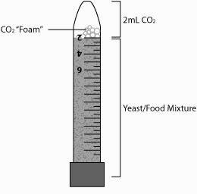

Graph:
Prepare a graph to summarize the data you recorded in the your data table.
- Label the Y-axis volume of CO₂ (ml)
- Label the X-axis time (min)
- Mark an appropriate scale
- Plot the data for yeast with sugar
- Plot the data for yeast with no sugar

The Effect of sugar on Respiration in Yeast

Conclusion Questions: YOU MUST USE COMPLETE SENTENCES

- Was your hypothesis correct? Explain why or why not using data from the experiment.

- Which set up was the control group?

- What is the independent variable (what was changed) in this experiment?

- What is the dependent variable (what was measured) in this experiment?

- Explain how the experiment may have produced data that was incorrect (sources of error)

- What experiment would you test in the future that relates to the ideas in this lab?

